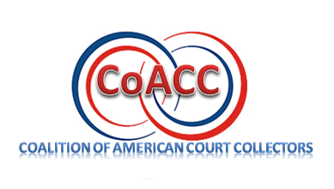
Membership will be available to any person employed by or responsible for the collection of revenue due a court entity or companies and/or consultants associated with internal court collections. Members will be required to pay an initial membership fee and after the first year, annual dues. Membership benefits include:

- Discounts on COACC seminars, workshops, and events.
- Special membership discounts on industry products, goods, and services.
- Exclusive access to a network of experience court collections professionals.
- Access to membership directory
- Subscription to association newsletter

The Coalition of American Court Collectors is proud to announce we are accepting new members. Membership fee is $75.00. Your new membership will immediately save you $50 off the price on the registration fee for the annual National Conference on American Court Collections.

Your membership can easily pay for itself within the year!

Complete the Membership form below in full and mail with payment in full to:
Coalition of American Court Collectors

c/o: Coalition of American Court Collectors
408 Chicago Drive, #594
Jenison, Michigan 49429

Coalition of American Court Collectors – Annual Membership

Name

Court or Organization

Street Address

City State Zip Code

Telephone Number

Email Address

Mailing Address (if different than address listed above)

City State Zip Code

___ Regular Membership: $75.00.

Note: If more than one individual is registering a separate membership form is required for each person. However, one check can be written to cover all individual memberships ($75 per each individual).

___ Corporate Sponsor: $500.

Signature/Title/Date: ___________________________________________________

